Assignment SQL & OOPS Ticket Booking System
Name: Shardul Satish Kulkarni
SupersetId: 5270707

Task 1: Database Design
Creating ER Diagram to understand relationships between tables:
- Active elements of the entities of TicketBooking System
  - Venue
  - Event
  - Customers
  - Booking
- Relationships,
  - Venue (1) ↔ (M) Event (1 to many, 1 venue can host multiple events at a time)
  - Event (1) ↔ (M) Booking (1 to many, 1 Event can have multiple bookings)
  - Customer (1) ↔ (M) Booking (1 to many, 1 Customer can have multiple bookings)
  - Booking Table ↔ Event Table (Indirect, connecting customer to the events table)
- Finding Primary Key:
  - Vid (VenueId)
  - eventide
  - customerId
  - BookingId
- Other Attributes
  - Venue
    - Vid (primary key)
    - venue_name,
    - address
  - Event
    - Eventid(primary key)
    - event_name,
    - event_date DATE,
    - event_time TIME,
    - venue_id (Foreign Key),
    - total_seats,
    - available_seats,
    - ticket_price DECIMAL,
    - event_type ('Movie', 'Sports', 'Concert')
    - booking_id (Foreign Key)
  - Customer Table
    - customer_id (Primary key)
    - customer_name,
    - email,
    - phone_number,
    - booking_id (Foreign Key)

  - Booking Table
    - booking_id (Primary Key),
    - customer_id (Foreign Key),
    - event_id (Foreign Key),
    - num_tickets,
    - total_cost,
    - booking_date,

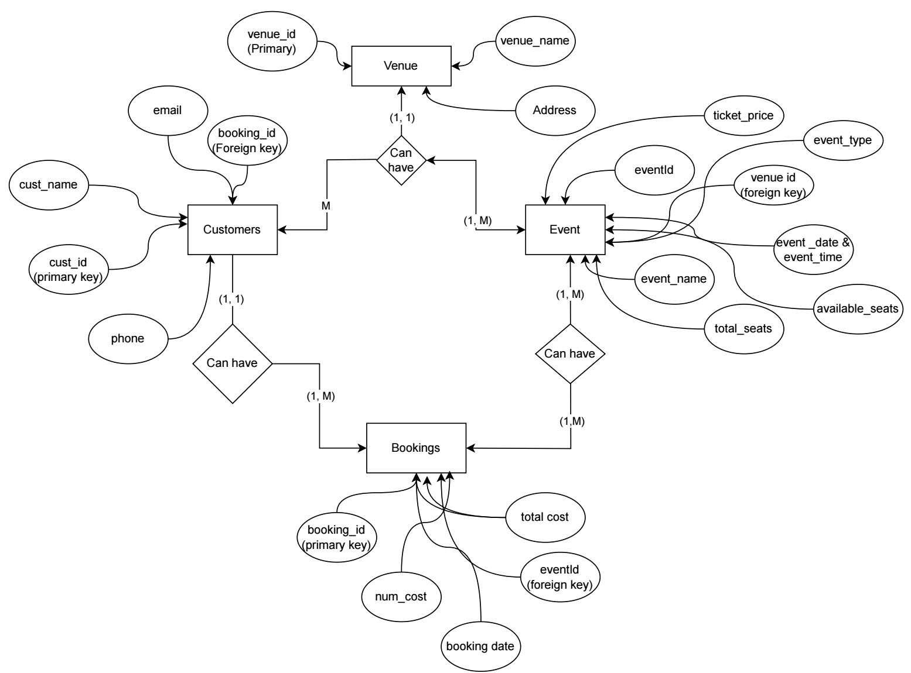

ER Diagram TicketBookingSystem

Process of Creating Database & Tables:
- Created Database named TicketBookingSystem by logging in MySQL Server as root
- Then Selected the database TicketBookingSystem to create tables in it.
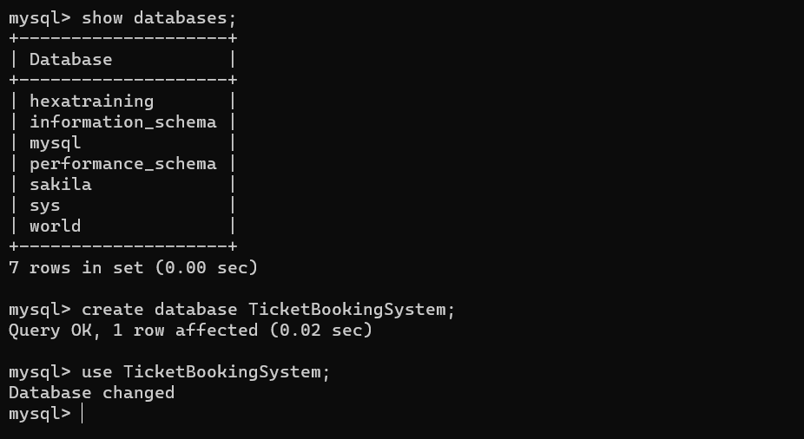
- Created required Tables in the database for the TicketBookingSystem
-- Active: 1742406895177@@127.0.0.1@3306@ticketbookingsystem
use TicketBookingSystem;
create table Venue (
venue_id int(10) AUTO_INCREMENT PRIMARY KEY,
venue_name varchar(25),
address varchar(100)
);
create table Event (
event_id int AUTO_INCREMENT PRIMARY KEY,
event_date DATE,
event_time TIME,
venue_id int(10),
total_seats int(100),
available_seats int(100),
ticket_price DECIMAL,
event_type ENUM('Movie', 'Sports', 'Concert') NOT NULL,
booking_id int(10),
FOREIGN KEY (venue_id) REFERENCES Venue (venue_id)
);

create table customer (
customer_id int PRIMARY KEY AUTO_INCREMENT,
email VARCHAR(20) UNIQUE NOT NULL,
phone_number int(10) UNIQUE NOT NULL
);
create table booking (
booking_id int PRIMARY KEY AUTO_INCREMENT,
customer_id int,
event_id int,
num_tickets int(50),
total_cost int(50),
booking_date DATE,
FOREIGN KEY (customer_id) REFERENCES customer (customer_id),
FOREIGN KEY (event_id) REFERENCES Event (event_id)
);

- Adding Foreign Key constraints to Customer, Event tables
Alter Table Event add CONSTRAINT FOREIGN KEY(booking_id) REFERENCES booking(booking_id);
Alter table Customer add column customer_name varchar(255);
Alter table Customer add column booking_id int;
Alter table Customer add CONSTRAINT FOREIGN KEY(booking_id) REFERENCES booking(booking_id);

------------------------------------------------------Task 1 Completed--------------------------------------------------------

